Question 20:
Make a dictionary of five songs and their durations. Access and print each duration.
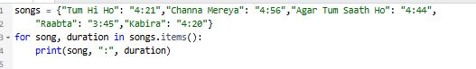
Output:
